Human Healthspan Scientific AI Network
White Paper · Version 1.0
A global network where everyone can ask, learn and contribute, and where approved researchers work with a private AI Scientist to help people live longer, healthier and more youthful lives.

1. Executive summary
Almost everyone cares about how long they will live, how well they will live, and how they look, feel and perform along the way. That shared human interest produces an enormous stream of questions, ideas and attention. On its own, though, it does not produce reliable knowledge. Serious research does produce reliable knowledge, but it is specialized, often closed, and disconnected from the questions ordinary people actually ask.
The Human Healthspan Scientific AI Network connects the two.
It is a worldwide platform with three purposes:
- Study and research how to extend human lifespan, make it healthier and keep people youthful.
- Build a supportive social environment for health, healthy routines and the development of ideas.
- Drive innovation in bioengineering, genome engineering, medicine and the AI that serves them.
To do this, the network combines three layers:
- An open community layer where anyone can discuss, ask, suggest and learn. It brings people in and surfaces what the world wants to know.
- A protected research layer where approved researchers and organizations turn questions into evidence, with governed data, evidence standards and structured collaboration.
- An AI layer with three coordinated systems: a General Platform AI for everyone, a Private AI Scientist for approved members, and Organization-Specialized AI for each organization.
The Private AI Scientist is the heart of the project. It is a proprietary, permission-controlled scientific intelligence, trained on how researchers actually think, and strengthened over time by the governed experience of the whole network.
The central bet is simple. Broad participation creates reach and questions. A rigorous research layer creates credibility. A private AI Scientist compounds the value of validated knowledge over time. None of the three works alone, and together they form something no single product in today's landscape offers.

2. The problem
The stakes are rising. The World Health Organization projects that one in six people worldwide will be 60 or older by 2030, and 2.1 billion by 2050, up from 1 billion in 2020. It also notes that the share of life spent in good health has stayed broadly constant, which implies that the extra years are being lived in poorer health (WHO, Ageing and health). Adding years is no longer the real challenge. Adding healthy years is.
People are asking the most important questions of their lives (how to age well, how to stay strong, how to protect their minds) in places that were never built to answer them well. Four gaps keep appearing.
Public interest and science are disconnected. People discuss health, longevity, fitness, skin and the brain in venues where quality is uneven and nothing connects the conversation to real research. Curiosity never reaches the people who could act on it.
Research is fragmented. Professional networks, health communities, research platforms, biomedical data platforms and AI research tools each cover one piece. No trusted place brings a social graph, a knowledge base, research workspaces, governed data and scientific AI together.
Evidence is not graded where people talk. A personal experience, an expert opinion, a preprint, a clinical trial and a pure speculation all look alike in a feed. Confidence ends up in the wrong places.
General AI is not built for confidential science. General assistants are fluent, but they are not governed for confidential research, they cannot keep one organization's knowledge apart from another's, and they do not learn from how researchers reason.
These gaps reinforce each other. Better public questions need better evidence labeling. Better labeling needs researchers. Researchers need collaborators, data governance and trustworthy AI. Trustworthy AI needs validated knowledge. Validated knowledge comes from research that exists to answer the public's questions. A point product fixes one gap and leaves the loop open. Only a connected platform can close it.

Why now
Three forces make the timing right.
Demand is rising. The WHO describes the pace of population ageing as much faster than in the past, and the UN has declared 2021–2030 the Decade of Healthy Ageing, which puts healthy longevity on the global agenda.
The target is clearer. Healthspan, not just lifespan, is now the measure that matters to people, health systems and researchers alike.
The tools have arrived. AI can now read, organize and reason across scientific literature at a scale no individual can. Inside a governed, private environment, it can multiply what researchers do instead of replacing them. What has been missing is a trusted place where that happens. This network is that place.

3. Vision and mission
Vision. A trusted global network where people, scientists, healthcare professionals, engineers, institutions, organizations and AI systems collaborate to turn questions and ideas into knowledge, research and responsible innovation that improves human healthspan, health, capability and potential.
Three missions carry the vision:
- Support the research community. Serve researchers, communities and organizations in biotechnology, DNA and genome science, health, protein science and human potential.
- Support people. Give everyone a place to learn, connect, discuss, share ideas and organize events, with the energy of the best professional and community networks.
- Train the AI. This is the most important mission: build an AI Scientist, provide comprehensive AI assistance to every user, and let organizations specialize AI for their own work.
This work is needed by everyone, and by the generations that follow. That belief shapes the design: no one should meet a blank page or an unexplained denial, and everyone should be able to take part. Ordinary participation is where research begins. Scientific rigor is how it becomes knowledge.

4. The concept: one network, three layers
The network is built as a single connected ecosystem, not a social site with a chatbot attached. Each layer has a distinct job, and each depends on the others.
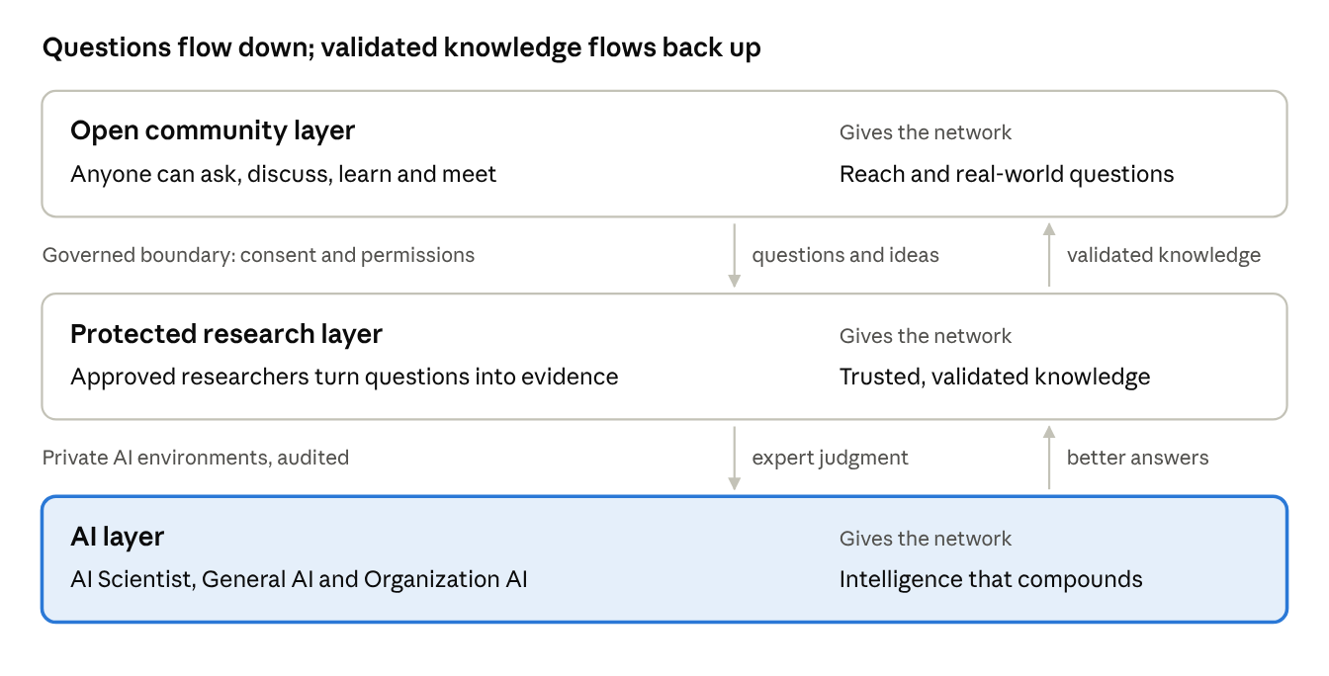
three layers and the flow between them
The open layer brings the questions, the research layer produces validated knowledge, and the AI layer compounds it and returns better answers to everyone.
The order matters. Participation without a research layer has no credibility. A research layer without participation has no reach. An AI Scientist without both has nothing proprietary to learn from.

The open layer: where curiosity begins
Everyone is welcome. The open layer offers community feeds, discussion forums, events, messaging, personal profiles and private health records that the owner fully controls. It takes its inspiration from the best of professional networks, open social platforms and community meetups.
People arrive through topics they already care about: skincare, fitness, sleep, focus, nutrition, appearance, healthy routines. This breadth is deliberate. Popular topics are the on-ramp, and each one leads somewhere deeper:
- Skincare leads to skin biology, then collagen and aging, then the cellular mechanisms of aging.
- Fitness leads to physiology, then muscle biology, then age-related muscle loss, then regenerative medicine.
- Brain performance leads to sleep and cognition, then neuroscience, then brain aging.

The research layer: where questions become evidence
Any user can apply to join a specialized research community. Approved researchers and organizations get a more technical environment: research workspaces, evidence tools, project and task management, publications, and a verified professional record of real contributions. Data here can be private, shared with a team, shared with a community or made public, always by explicit choice.
Organizations such as laboratories, universities, companies, institutes and clinics are first-class citizens. Each has its own members, roles, projects and AI, and its confidential work stays isolated from everyone else's.

The AI layer: where knowledge compounds
Three AI systems serve three different audiences, each with its own boundary (Section 8). Together they turn a growing body of questions, evidence and expert judgment into a scientific intelligence that gets better with every validated result.

5. The value loop
The engine of the network is a loop:
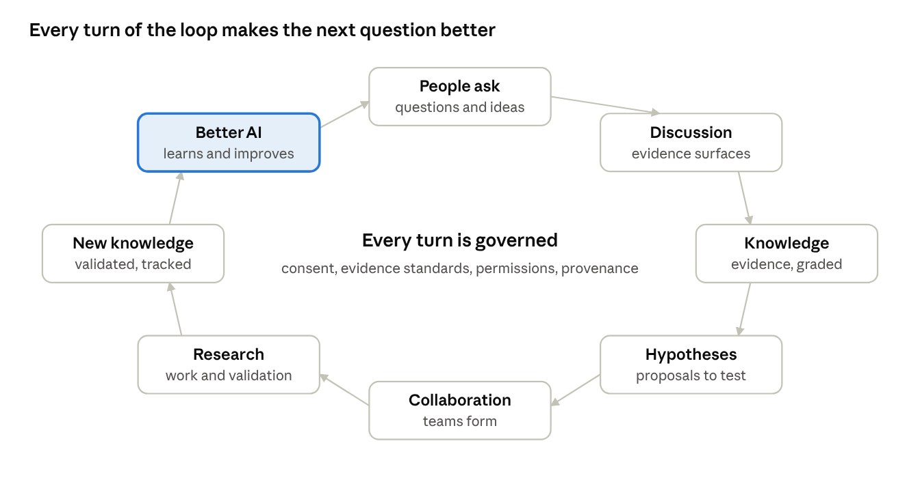
the value loop · 8 stages, one direction
People ask. Discussion surfaces evidence. Evidence is organized into knowledge. Knowledge suggests hypotheses, which attract collaborators and become research. Validation creates new knowledge, which improves the AI, which helps people ask better questions.
Two properties make this loop different from ordinary engagement.
First, it crosses from the open layer into the protected layer and back. The boundary between them is a central design focus, and the platform's most careful engineering lives there.
Second, every turn of the loop is governed. Consent, evidence standards, permissions and provenance apply at every stage, and no stage may bypass approval or access control.

The member journey
For an individual, the loop appears as a path from curiosity to contribution:
Discover → Learn → Connect → Participate → Collaborate → Research → Validate → Share appropriate knowledge → Inspire new questions.
The product is designed to move people along this path, not to maximize time on site. A person who starts with a question about sleep can end up contributing to real research, and the network is built so that this progression is natural, visible and safe.

6. Guiding principles
Principles matter only if they settle arguments. These are the ones that shape every decision in the network.
People-first, science-led. Serve people's real questions with scientific rigor and honest labels of evidence.
Separate the kinds of knowing. Personal experience, general information, expert interpretation, scientific evidence, AI-generated hypotheses and speculation are different things, and the platform never blurs them. "This routine worked for me" is valuable community information. It is not a medical claim.
Popularity is not credibility. Followers and likes measure attention. Scientific reputation is earned through evidence quality, peer review, reproducibility and verified contribution, and the two signals are kept apart.
Protect what is sensitive. Personal health data, genomic data, confidential research and the proprietary AI are protected assets. They are private by default and shared only by explicit consent.
Navigation is not authorization. Opening a portal never grants access to anything. Permissions are checked on every protected action.
AI inherits the user's rights. No AI system can see more than the person using it is allowed to see.
AI proposals are not discoveries. Fluent output is not verified fact. Hypotheses from AI need independent validation, and humans remain responsible for scientific judgment.
Provenance is visible. Important knowledge carries its source, method, version and review status.
Learning is authorized. Not every upload or conversation becomes training data. Learning requires rights, consent and review.
Value is contribution, not engagement time. Success means learning, collaboration and responsible research.
When principles conflict, the order of precedence is clear: safety, privacy and consent first; scientific credibility second; research usefulness third; growth and monetization last. A growth tactic that weakens credibility is rejected. A training shortcut that weakens consent is rejected. Anything diagnostic or clinical waits for proper regulatory review.

7. Scope: broad on purpose
The network covers ten connected areas:
- Biotechnology and bioengineering
- Genome engineering and DNA research
- Protein and molecular research
- Lifespan, longevity and healthy aging
- Medicine and healthcare
- Brain capability and cognition
- Skincare, hair care and appearance
- Bodybuilding, fitness and strength
- Healthy routine: nutrition, sleep, habits and environment
- AI for science and human potential
These areas are connected, not isolated, and the platform supports research and discussion across them. Some are scientifically mature and some are young, and the platform is honest about that difference. Each topic carries a visible maturity label so that a popular subject is never mistaken for a settled one.
The main goal does not change: longer, healthier, more youthful lives. The broad scope exists because ordinary interest is the way people reach that goal, and because the connections between fields are where new questions come from.

8. The AI ecosystem
The AI is not a feature inside a portal. It is a separate and central part of the network, made of three systems.
AI system | Serves | Knowledge boundary | Role
Private AI Scientist | Platform-approved members | Authorized scientific corpus, projects and datasets; fully private to the platform | Research, strategy, evidence, scientific thinking
General Platform AI | Every user | Public knowledge, common platform data, web search, third-party AI providers | Questions and answers, education, discovery, trend understanding
Organization-Specialized AI | Members of one organization | That organization's own knowledge and data | Specialized research and assistance for the organization's purpose

The Private AI Scientist
The AI Scientist is the most important asset in the project. It is built to research, study, plan strategy, collect evidence and reason the way researchers, scientists and professors do in biotechnology, genome science, health, protein science and human potential.
It works from a private knowledge environment: curated and rights-cleared literature, permissioned datasets and approved research activity, all with provenance. It can support specialist capabilities such as literature review, evidence assessment, genetics, protein science, aging biology, bioinformatics and research planning.
What sets it apart is what it learns from. Most AI is trained on documents. The AI Scientist is also trained on how members research: how they choose important problems, frame questions, search for evidence, weigh conflicting findings, form hypotheses, choose strategy, interpret results and change their minds. Approved, reviewed research activity becomes structured learning, so the AI Scientist absorbs the practice of science and not only its publications.
It then helps decide where to look next. It finds contradictory evidence, underexplored topics and available data, and it proposes high-value questions to researchers as opportunities and hypotheses. People make the scientific judgments and run the real experiments.
It stays private by design. A general chatbot cannot be allowed to become a backdoor into confidential research, so the AI Scientist lives in its own environment with its own indexes and narrow, audited interfaces.

The General Platform AI
The General AI makes the network useful to everyone from the first minute. It explains health and science with clear evidence labels, answers questions, summarizes, translates, helps people navigate the platform, and recommends people, communities, topics and events. It can discuss trends and estimates where they are defensible, shows its sources, and keeps facts apart from estimates. It works with leading third-party AI providers through a provider-independent gateway, so the network is never locked to a single model.

Organization-Specialized AI
Each organization can build its own AI on the platform's base model support. It has its own knowledge sources, access rules, evaluations and usage records, and it can be adapted to the organization's purpose. One organization's confidential knowledge never reaches another organization, or the public platform.

The shared experience loop
The three systems learn from one another, but only through a controlled process. The General AI contributes broad experience: what people ask and where interest is growing. Organization AI contributes focused, domain-specific research experience. Approved researchers contribute judgment and expert-reviewed examples. The AI Scientist improves from all of it.
Every contribution must be authorized, rights-cleared, source-tracked and quality-reviewed, and wherever possible it is de-identified or aggregated first. Private conversations, confidential research and personal health data never flow into the AI Scientist automatically.

What "training" actually means
The network is precise about the word. Customizing prompts, retrieving from a knowledge base, fine-tuning a model and training a model are four different things. A knowledge base alone does not make a trained model. The network starts with the first two, adds the third where evidence shows it helps, and moves toward proprietary model development as data, rights and evaluation mature. Each step is measured against a simple test: does the AI Scientist demonstrably do real scientific tasks better than a general model?

9. Trust by design
Serious researchers will use the network only if they trust it, and the public will use it only if it is honest. Trust is therefore built into the concept, not added afterwards.

Honest about evidence
Every claim on the platform can be understood for what it is. Evidence is classed from peer-reviewed research and clinical trials, through observational, animal and laboratory findings, computational results and preprints, down to expert opinion, community experience, AI-generated hypotheses and plain speculation. Evidence records keep their source, study type, population, methods, limitations and review status, and confidence labels never imply false precision.
Four mechanisms keep quality high:
- Reputation separate from popularity. Scientific standing comes from the quality of research contributions, not follower counts.
- A collaboration engine. A user submits a research question. The AI finds related concepts, evidence, gaps, datasets, experts and existing projects, then proposes collaborators and a structured workspace. "I have an idea" becomes "here are the people, knowledge and data needed to investigate it."
- Research discovery. The AI Scientist helps answer "what should we research next?" with opportunities and hypotheses, never autonomous conclusions.
- Scientific oversight. As the community matures, an advisory group spanning molecular biology, genetics, medicine, aging research, AI, statistics, epidemiology and bioethics sets review standards, evidence policy and conflict-of-interest rules.

Data kept in separate categories
Identity, health, professional, research, scientific knowledge, files, search, AI operations, subscription and governance data each live in their own category, with their own owner, permissions, consent and retention rules. This makes research easier, protection stronger and each AI's boundary enforceable.

Health data belongs to the person
Personal health records are private by default. The owner decides, record by record, whether to share with connections, specific people, authorized organizations or time-limited links, and can revoke that access. Health data never silently becomes research data or AI training data. Any such use requires separate, explicit consent and governance that respects health, genetic, research-ethics and cross-border rules.

Trends understood responsibly
The network learns what people are curious about: emerging topics, popular questions, and where members seek knowledge or collaboration. This improves discovery, guides communities and events, and shows researchers where new opportunities may lie. It does so transparently, with aggregated signals and user control, and without exposing any individual's sensitive interests.

10. The experience
The network is one account with several experiences, each shaped for its audience.
- Social Portal. The public front door: feed, discussions, events, messaging and communities.
- Personal Portal. A member's own space: profile, verified credentials, badges and private health records.
- Researcher Portal. The research workspace: evidence tools, projects, organizations and the AI Scientist.
- Administration. A separate application for moderation, verification, subscriptions, AI monitoring and security.
People who have not joined a research community still find a useful experience, not an empty page: topics, communities, experts, public events and clear routes to apply. Research access follows role, community, organization and project, and visibility is set resource by resource, so a public summary can never expose private attachments, unpublished results or confidential discussion.

11. Challenges and how the network answers them
Every major risk in this concept has a designed response and a signal that shows whether the response works.
Challenge | How the network responds | How we will know
Public curiosity never reaches research | Popular entry topics with a visible path into deeper science, and open applications to research communities | Share of members who join a research community or contribute to a project
Research tools are fragmented | One account with evidence tools, workspaces, governed data and AI in one place | Active projects and cross-organization collaborations
Evidence is not graded | Evidence classes on every claim, and evidence records with source, method and review status | Share of discussions linked to a classed source
Medical or scientific misinformation | Evidence labels, moderation, expert review and no outcome promises | Moderation response time and acceptance of expert corrections
AI hallucination | Retrieval with citations, calibrated uncertainty and human review of consequential output | Citation accuracy and expert-rated usefulness
Confidential research leaking | Separate AI environments, private indexes, inherited user rights and audit trails | Zero cross-boundary incidents
Health and genomic privacy | Private by default, explicit consent, separated data categories and jurisdiction-aware compliance | Consent compliance and unauthorized-access incidents
Cold start and low engagement | A few high-value communities, expert content, events and popular topics as entry points | Repeat participation and retention
Scientific credibility | Verified researchers, reputation kept separate from popularity, and advisory oversight | Expert adoption and reproducibility of shared work
Regulatory exposure | Clear positioning, with legal and regulatory review before any clinical or diagnostic feature | Reviews completed before any such feature ships
Unvalidated training data | Rights checks, opt-in, provenance and review before any training | Share of training data with documented rights

12. The approach
The vision is large, so the approach is deliberately disciplined. Four ideas guide how the network is built.
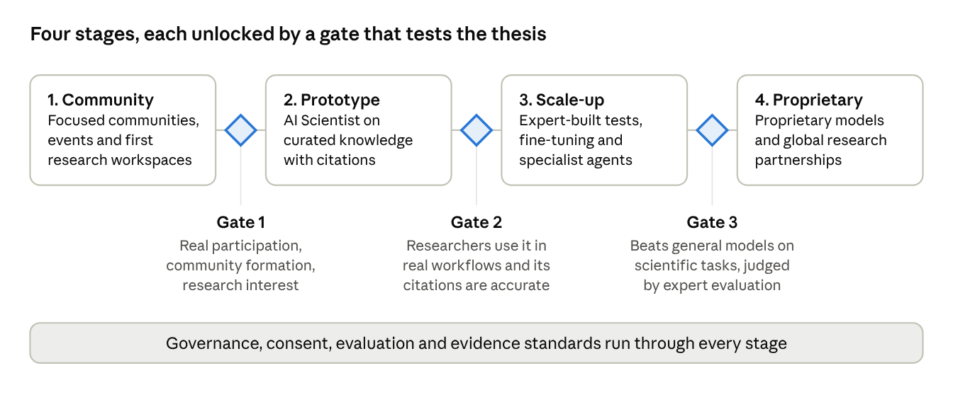
staged roadmap · 4 stages, 3 gates
Each stage ends at a gate. The next stage begins only when the gate's evidence is in.

Build the smallest credible system first
The network begins with a focused set of high-value communities and a small number of research workflows, not every discipline at once. The first release is judged on four things: real participation, community formation, genuine research interest and useful, AI-assisted collaboration. A large number of screens is not the goal.

Let the AI grow in stages
The AI Scientist begins on the best available foundation models, supported by curated, permissioned knowledge with citations, and serves a few research workflows with real researchers. It then deepens only as evidence supports: expert-built evaluation sets, task-specific fine-tuning, specialist agents for literature, genetics, protein science, aging and bioinformatics, and, over time, proprietary models. Evaluation never stops. It covers factual accuracy, evidence quality, citation accuracy, calibrated uncertainty, reproducibility, privacy and real usefulness.

Grow trust before growth
Consent, isolation and auditability are earned over time. Institutions will not move confidential work to a platform they do not trust, so the network invests in governance early, even when it would be quicker to skip it.

Measure what matters
Success is valuable participation, not time on site, likes or content volume. The network watches whether members form meaningful discussions and keep coming back, whether questions become projects and collaborations, whether the evidence behind discussions improves, whether the AI's citations and assessments are accurate and useful to experts, whether permission and privacy incidents stay at zero, and whether organizations adopt the platform and find real value in it.
The network is built on a modern, modular foundation that can scale from a small first release to a global platform, with independent applications, a shared account system and an AI platform that can grow and be deployed on its own. The technical detail belongs in the architecture documents. What matters here is the promise: the platform is designed to expand without being rebuilt.

13. Why this is hard to copy
The network's advantage is the combination of five things that reinforce one another.
- The Private AI Scientist. It is trained on curated, rights-cleared, expert-reviewed knowledge and on how approved researchers study and decide, and it is private by design. A competitor cannot reproduce it by wrapping a public model.
- Validated, provenance-tracked knowledge. It accumulates only through real research activity, with ownership, evidence records and review.
- Trusted governance. Consent, isolation and audit are earned slowly and lost quickly. Once earned, they are a durable advantage.
- Network effects across three groups. The public brings questions and energy, researchers bring credibility, and organizations bring depth. Each group attracts the others.
- Organization-specialized AI. Each organization's own knowledge and workflows deepen its relationship with the platform without exposing it to anyone else.
The market today is fragmented into professional networks, health communities, scientific R&D platforms, biomedical data platforms and AI research tools. Each covers part of the picture. The network's position is the integration.
Positioning. A global network for human health, potential, scientific research and AI-powered innovation.
It is not another social network with a chatbot, and it is not merely a repository of documents. It is a connected ecosystem in which broad participation creates questions, research communities turn them into structured science, and a private AI Scientist helps authorized members work with evidence, plan research and build knowledge.

Sustainability without compromise
The business model grows from validated value: free community participation; premium learning and AI features for individuals; subscriptions for researchers, teams and organizations; paid organization creation, events, contributor badges and Organization AI; private deployments for institutions; and, where rights, privacy and scientific validity allow, specialized AI and data services. One rule governs all of them. Monetization must never undermine scientific credibility, privacy or trust, and sensitive personal or research data is never treated as an unrestricted commercial asset.

14. Responsible by design
The network is honest about what it is and is not.
- It is not a medical provider, an autonomous doctor or an "immortality" service. It promises no health, appearance, performance or longevity outcome, and its information does not replace qualified medical care.
- Any feature that could be diagnostic or clinical receives legal and regulatory review before it exists.
- AI output is shown with its sources and its uncertainty, and consequential output is reviewed by people.
- Scientific claims are labeled by the strength of their evidence, and community experience is never presented as medical fact.
- Health and genomic data are protected, consent-based and purpose-limited, with respect for the laws of each jurisdiction.
- Research data and models carry clear ownership, licensing and attribution.
These commitments are not a constraint on the vision. They are what make the vision credible to the people whose participation it needs.

15. Conclusion
The Human Healthspan Scientific AI Network starts from a simple observation: the world is asking exactly the right questions about health and longevity, and the world's researchers are equipped to answer them, but there is no trusted place where the two meet.
This network is that place. A broad and welcoming community layer brings in the questions. A protected research layer turns them into evidence. A private AI Scientist, trained on how researchers truly think and strengthened by the experience of the whole ecosystem, sits at the center and grows more capable with every validated result. Strict separation of data, consent-based use of health information, permissions enforced at every step and honest treatment of evidence keep it trustworthy. A staged, disciplined approach keeps it buildable.

An invitation
The network grows through the people who join it first.
- Researchers and clinicians: help set the evidence standards and shape the AI Scientist's first workflows.
- Organizations: bring a laboratory, institute, university or clinic into a governed environment with its own private AI.
- Partners and funders: support a platform built to turn public curiosity into validated science.
- Everyone else: ask a question, challenge an idea or join a community. Research starts there.
Its purpose is a single, shared one: longer, healthier, more youthful lives for all people, and for the generations to come.

Sources
- World Health Organization, Ageing and health, fact sheet, 1 October 2025 (accessed November 2026).

